Next we have Demaographics

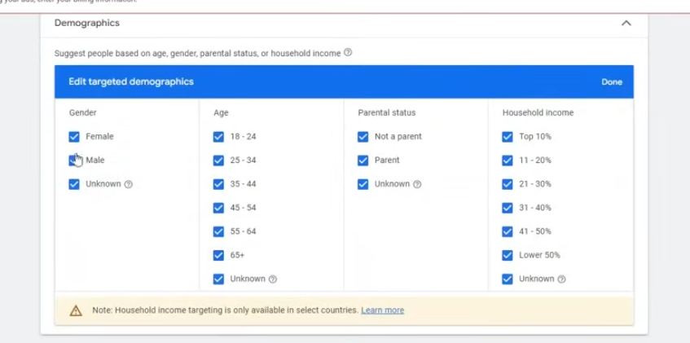
Now thing we need to understand is keyword , tropic and placement
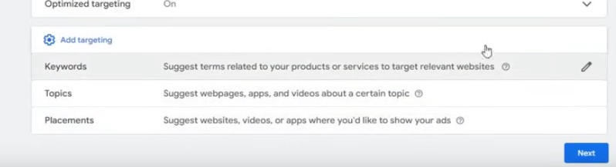
First we undertsand
you can target keyword

we pick it up randomly from the right as shown above

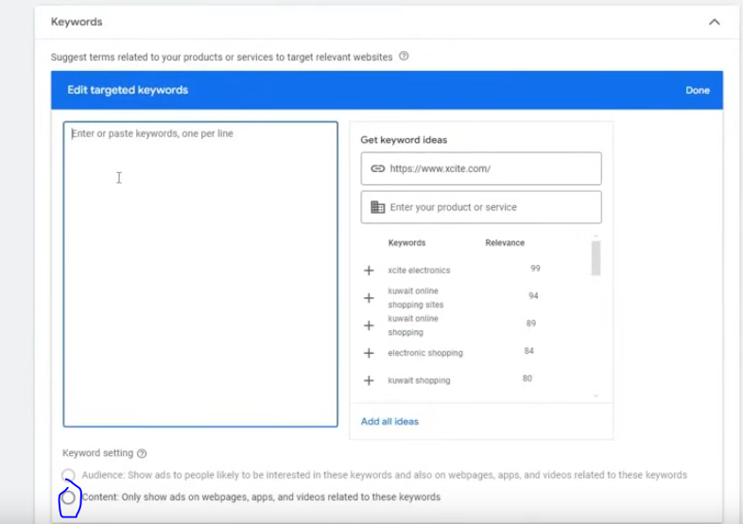
Here we have only one option marked above
It means this ad will be shown on the websites where these keywords are present
you can add your own keyword also
Nect thing we have is topic

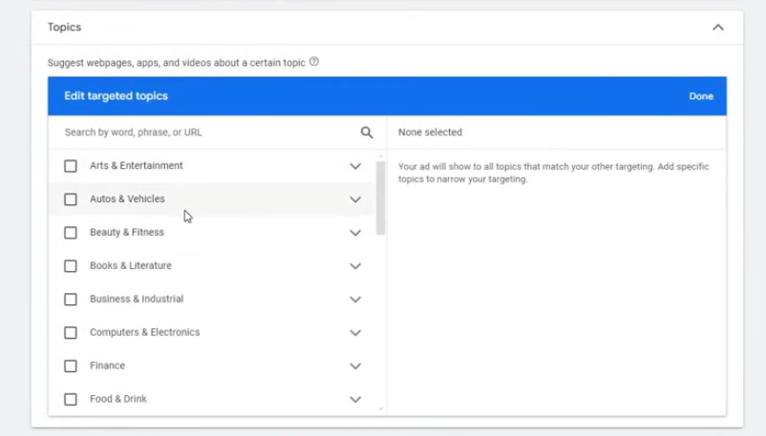
We can search a topic here
and if a website is made on that topic then ad will be shown on that website
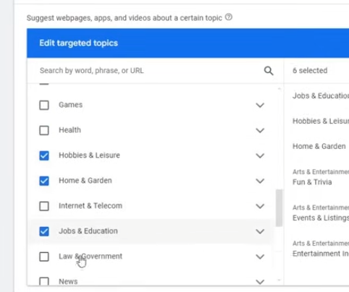
For example we ahve some political ad then we can run target topic like News , Law and Governement , People and Society

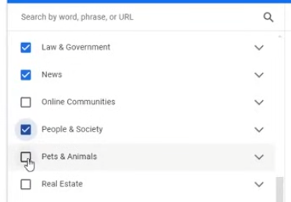

If the ad is rtel;ated to animals then you can target the topic pets and animal

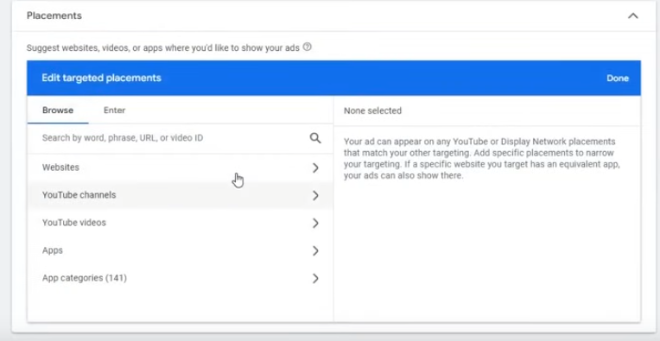
Now comes the placement

You can use your rival website or any other website you can run ad on them
It will not happen that you target a website and ads will immediately start running
Basically the owner of the website applty for google ad sense
It is an agreement in which the owner agree that the aadvertiser can run ad on there website due to which revenue is generated
you can even target youtube channels
If you want to target exactly a url then go to enter tab

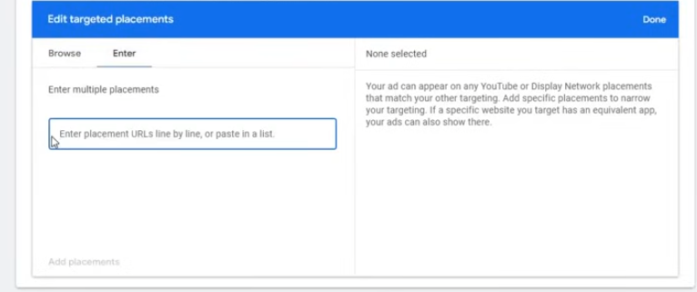
and then type the url in the field above
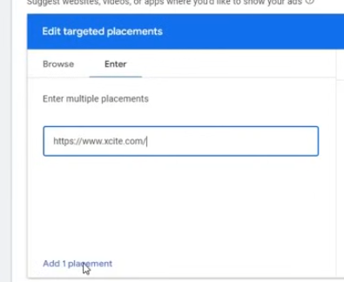
click on add 1 placemenr it will be added

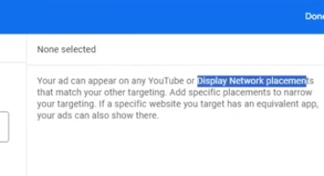
You can even targert youtube videos . You can run ad even on theie apps

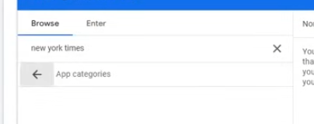
You can even target specific app categories

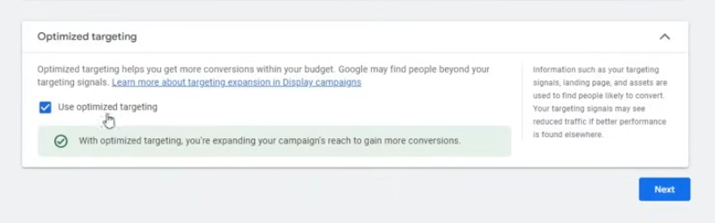
Now in optimised targeting
Keep it on it is a best practise (who knows)
Now we have understood everything Now how to use it
To use it you don't have to restrict your audiecne too much
Try the audience in – makret if you get thisbthen it will be good
It wil be beter if you set the dempgraphics
Always try that you don't have to go to Keywords, topic, placement and you get your audience in
Audiecne segment and Demographics etc
This is because by this hyou restrict your audoience too much
If you use only one of the option for each campaign
For example if you are targeting topics or placement
If you do it all then it leads to a combination which will be very small in number to whom google will not be able to reach out
So teacher recommends that target by Demographics and placement(I don't know)

Now click on next button

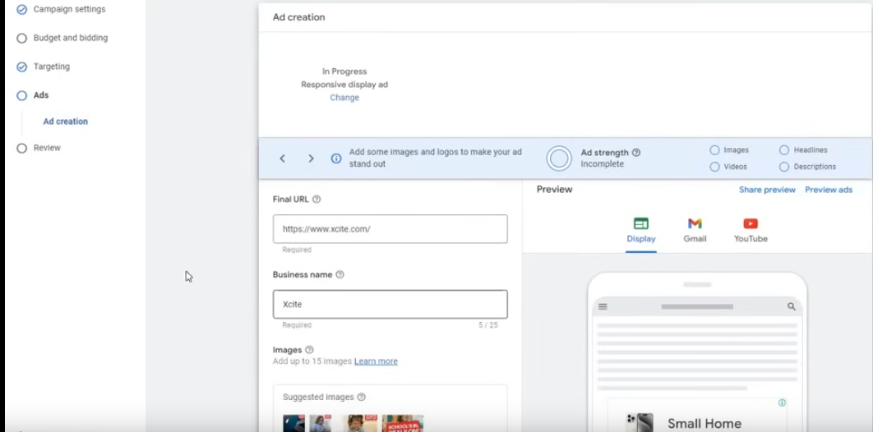
Now we will see how Display aads are formed and how they look we come in this process and HO to set up them

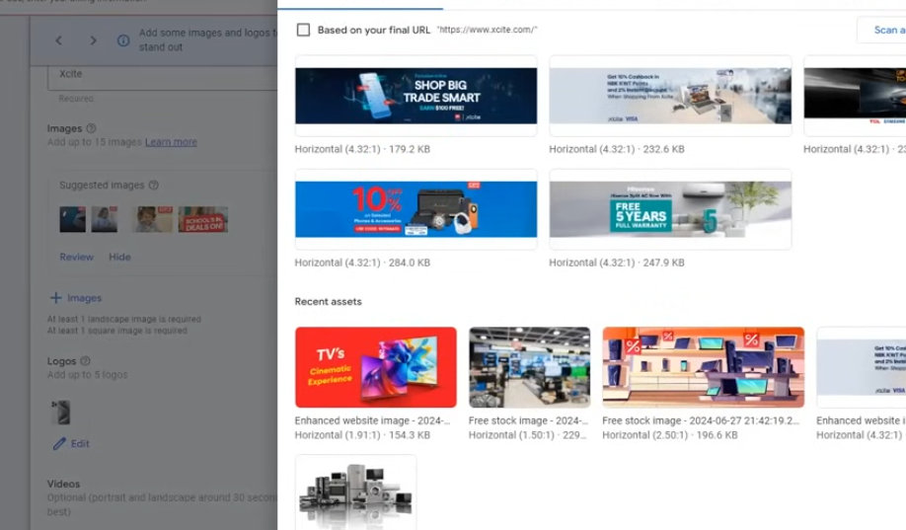
In this at least 1 ladnscape and a squar image is required

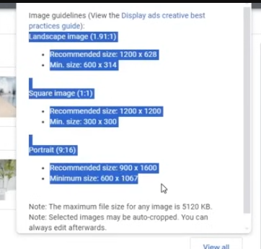
Click on question mark to display teh guidelines

So make three sizes of same design
You can add upto 15 images it means that you make 5 design abd create three sizes of each

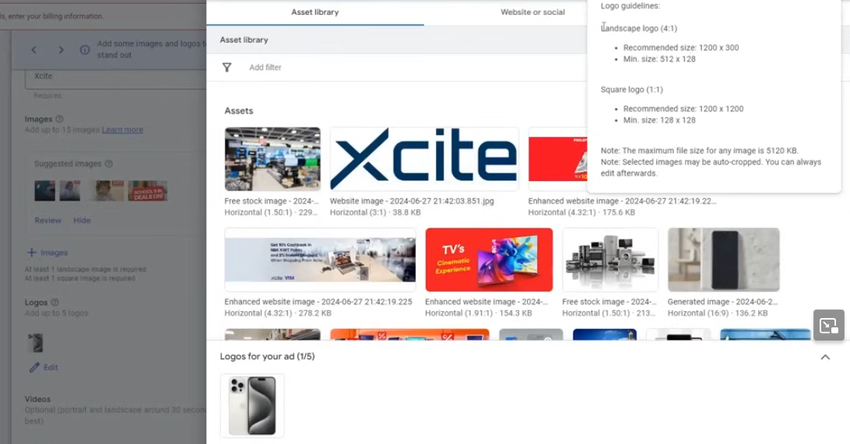
Logo is generally one
It requirement is Landscape logo and Square logo
and then the videos are optional It all depend on you do you wnat it or not
If you don't want it then google will aautomatically make it(who knows)
It is saying that videos whether portrait or optional
If you have then give it to here
Headlines limit is 5 always try to add all teh headlines

and you can add long headline only 1
and 5 desscription are allowed

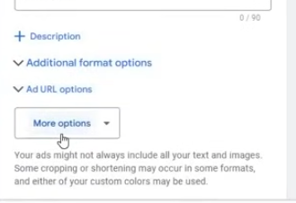
Click on More option
and then in submenu click on call to action text

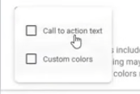
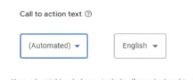
Set it from automatic to anything you want

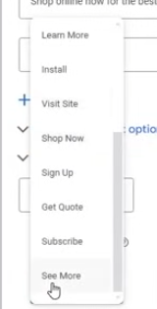

By this a complete display ad will be formed
Display or video campaign (who knows) is mosly used for remarketing or for expansion , scaling
Now we come to Demand Gen or Remaarketing Gen
First we will see Display ds will be shown where

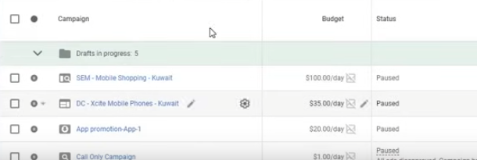
so clic oin campaign and then click on ad group
and hen reach ad

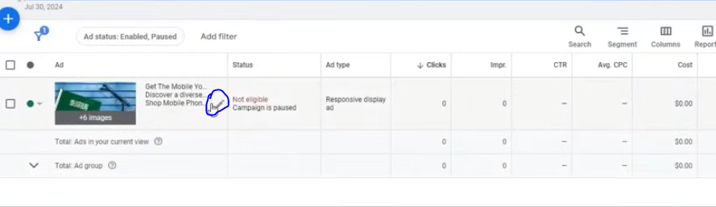
Now click on edit button as marked above

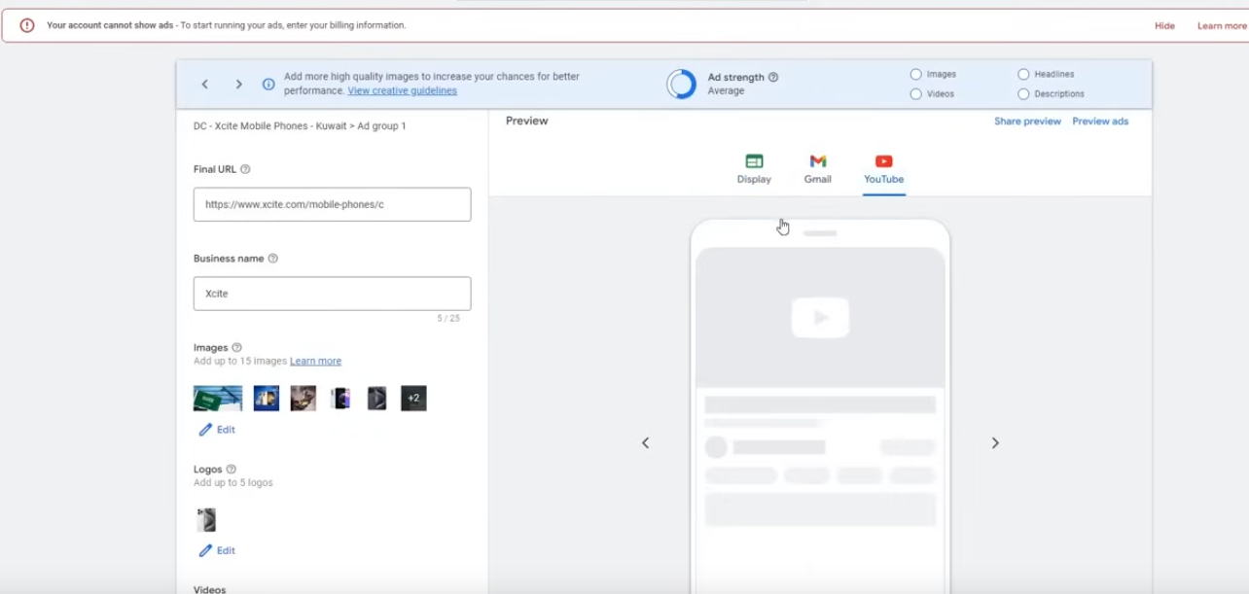
Your display ad will be shown on Youtube , Gmail or display , different website or apps
You can see there preview ho they aare shown
Now we move to Demand Gen

Lesson 17:-
In this lesson we will learn about Demand Gen Campaigns
Now we start Demaand Gen camaign It will be very short campaign
It don't have any special details because we have already covered too much
Phase 38
So we create new campaign and choose campign goal and then choose campaign type Demand gen

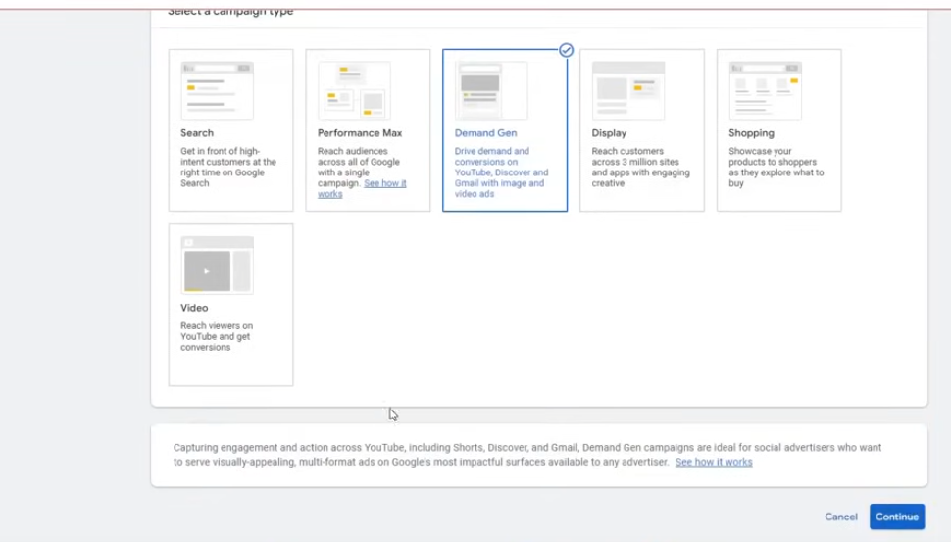
It is newly introduced It haas been since it is introduced
click on continue
and it is similar to Display ads

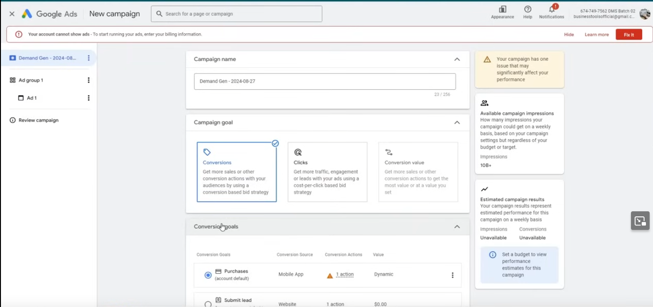
but in this ad run on specific format

Now its interface is similar to Meta Ads
Now it ask you campaing goal you choose Conversion for lead generation and aand conversion values for Ecommerce
and do conversion value only when you have value configured tracking happening
If it is not happening then choose conversion
Choosing click will not give anythig because according to the teacher we want sales not clicks

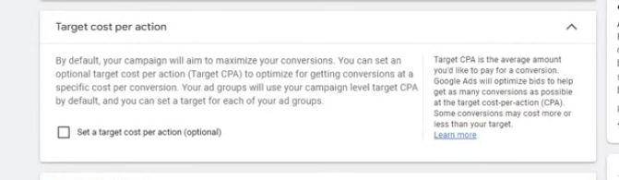

Do not set traget cost per section becasue we initially does not know that how much cost will be reached (who knows)
6:31:00
Teacher recommneds it shoulkd be 50

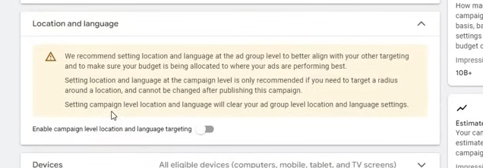
ther are some recommendation that if we do not follow hten it ill be good

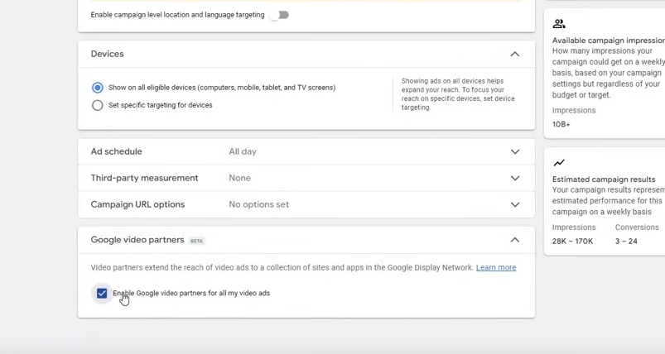
Self explanatory

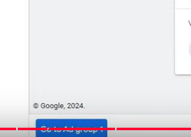
Now go to Create Ad group

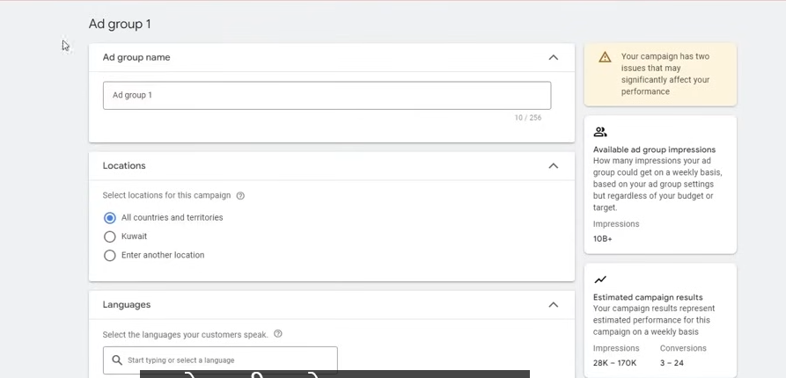
Now in ad group we get the location and languages
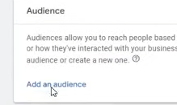
Now add an audience

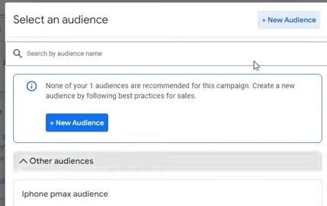
No click on New Audience

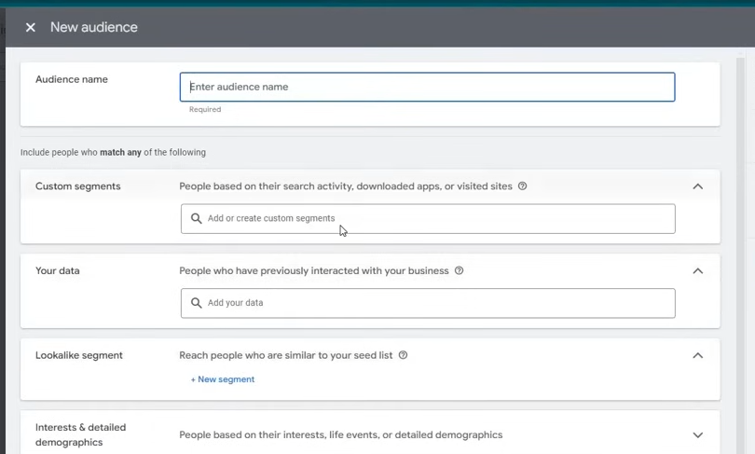
Now you creat new audince here
Whever match woth the interest you mentioned will be shown there

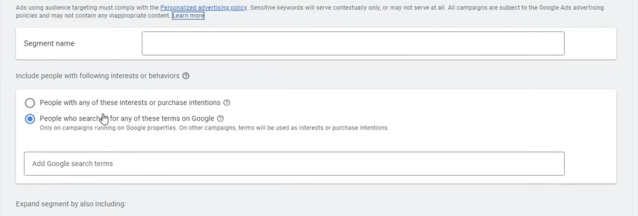
create ausince segment (who knows)

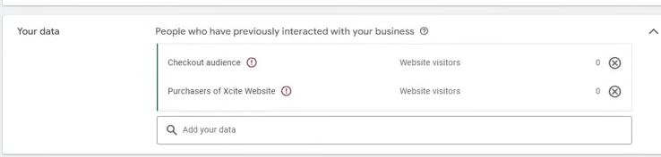
Add your visitors data here

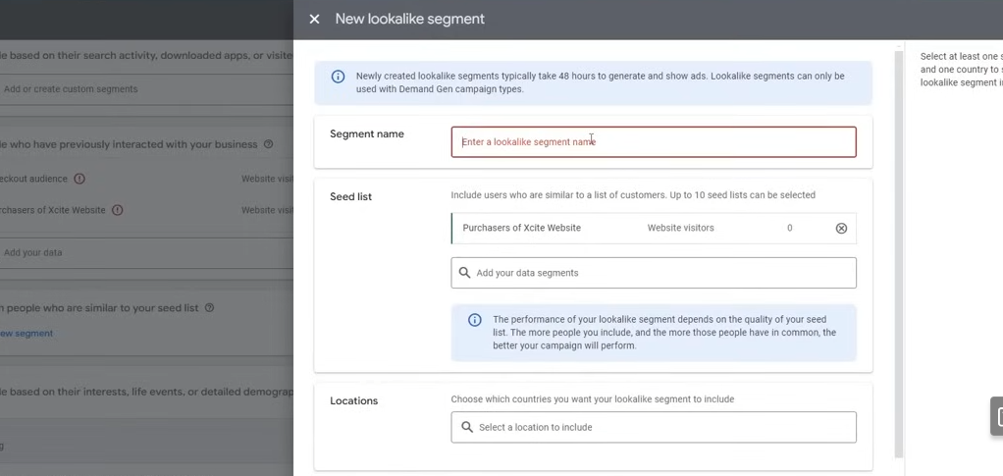
It will be used to find lookalike aaudiecne

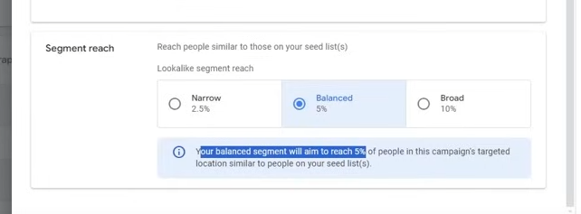
Now if you choose 5 percent then 95 percent of audience will be through the audiecne you choose in campaaign an 5 percent will be look laike you can choose other options
you van trget your audience on the bassi of ther interest and also exclude them

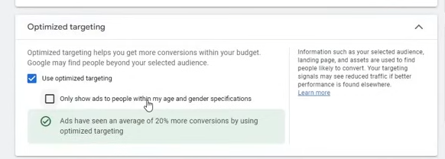
Keep it enabled

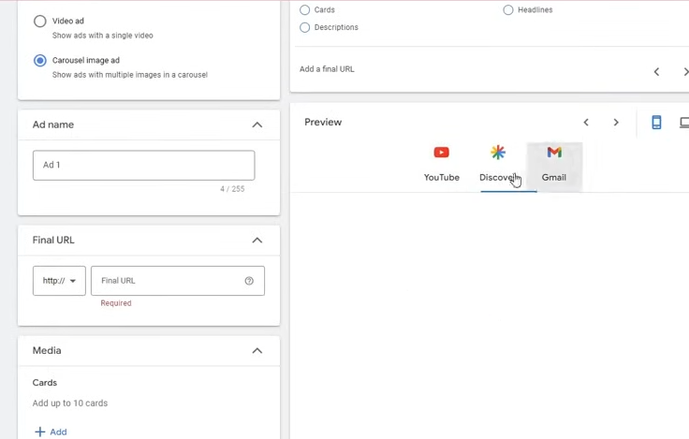
Now in ad level set your
The image is similar to diaplay ad
and the video ads is simlar to youtube ads

you can aadd our sitelink here

what is sitelink
A sitelink is a feature commonly used in search engines like Google, particularly in the context of search ads or search engine result pages (SERPs). It allows users to see additional links beneath the main search result. These links typically lead to specific pages of a website, making it easier for users to navigate to the exact information they are looking for without having to visit the homepage first.
IN courousel you can add cards
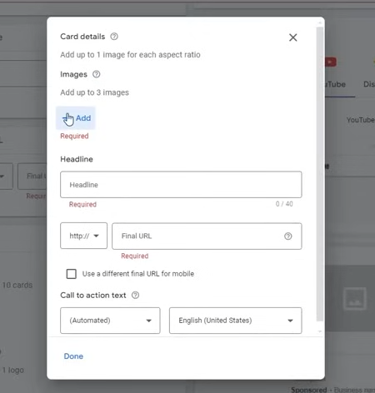
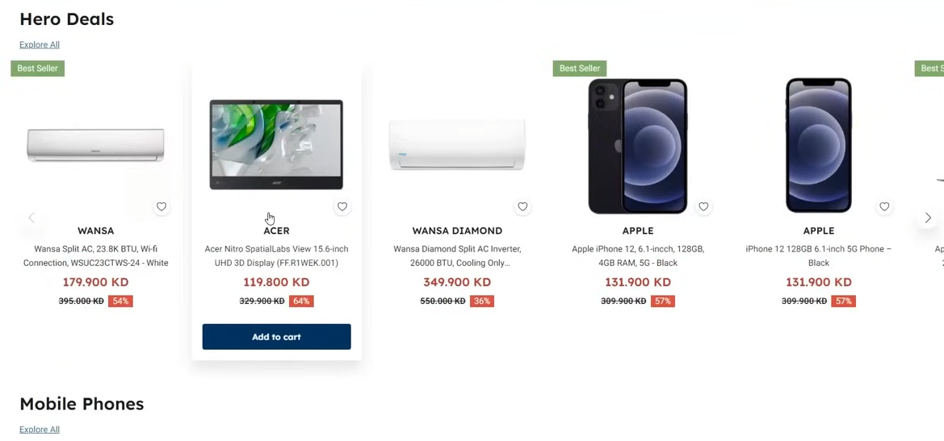
This is the Goal

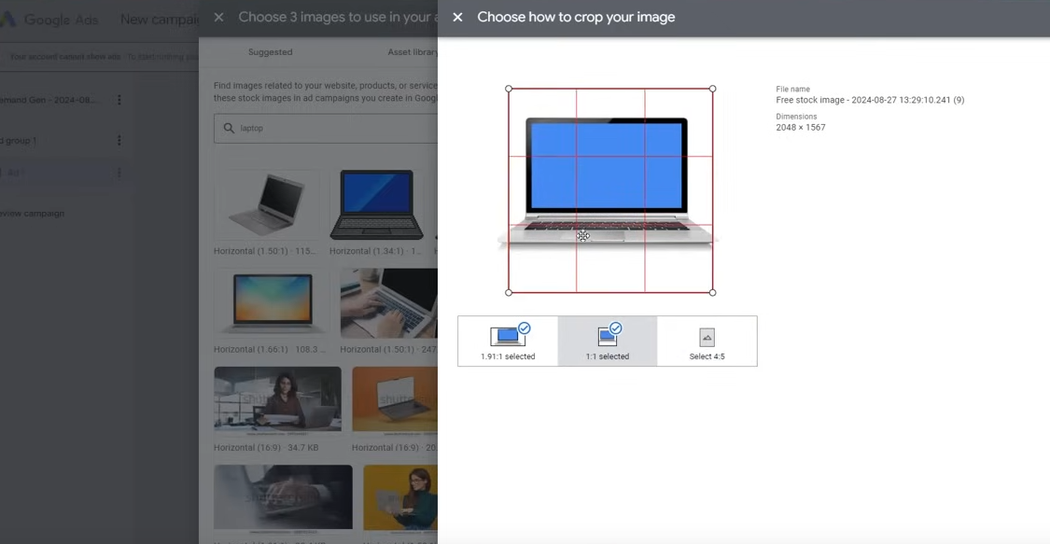
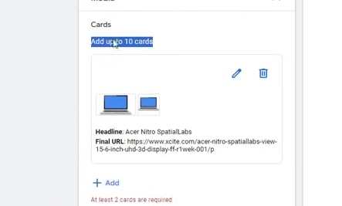
You can add upto 10 cards

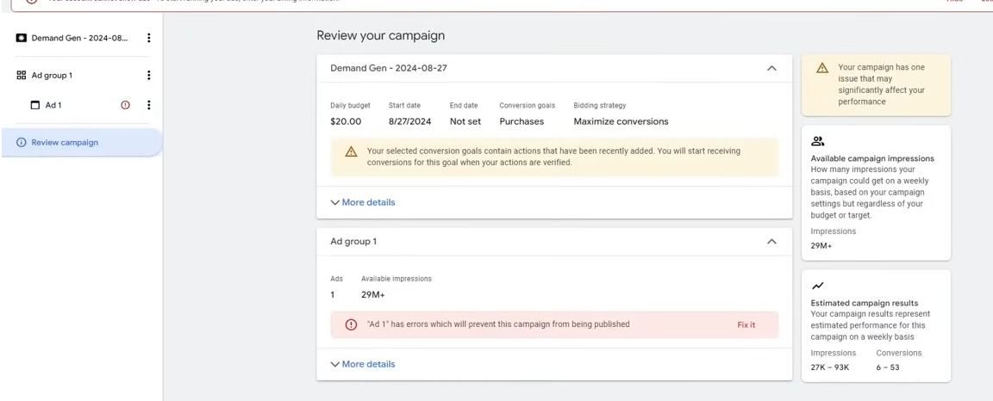
Our Demand gen is completed
Now we will learn Remarketing campign

Lesson 18:-
In this lesson we wil learn about Remarketing Audience
It is not anything seperate campaign it is just we basically make a remarketing audience and then inside campaign we choose that remarkeeting audience
For remarketing teh best campaign is display and video
In this you use remarketing audince
you can also use Demand Gen
these campaigns are recommended for remarketing you can use them
Phase 39
Basically what happens we make an audience list and htne we choose our remarketing audeinece in our campaign
But before this you need to pre steps
when you set up some new account you need to do this step there sp that you don't have to wait later that data should be collected

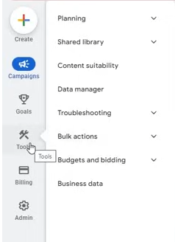
Go to Tools and then to Shared Libraries and expand it and then go to Audience Manager

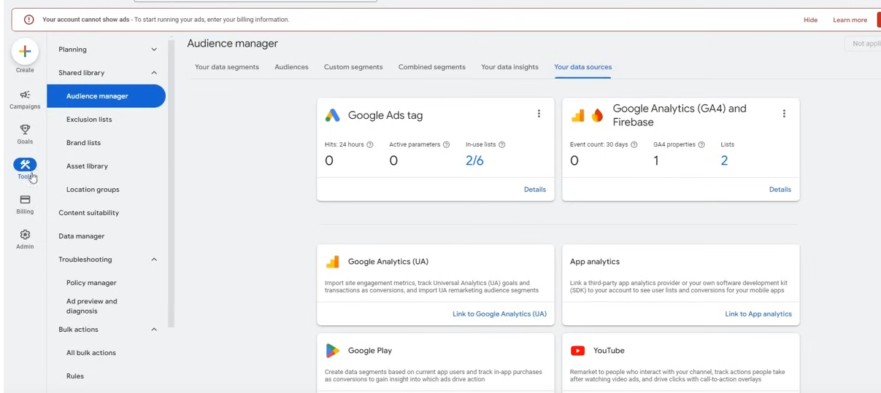
Now go to your data sources and then to Details
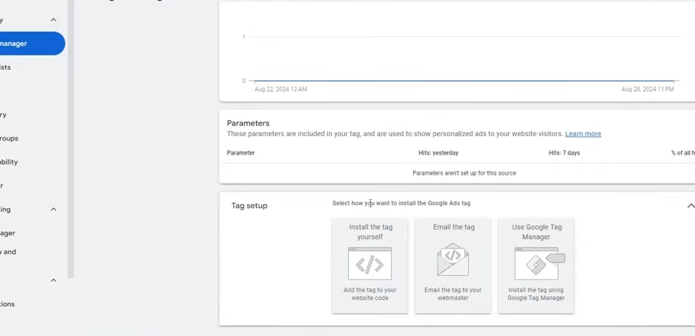
and no there will be code of remarketin which you will add in your website and when you make remarleting audiecne there tath data will be collected

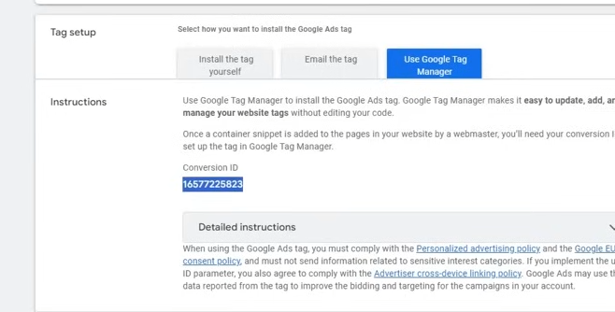
We choose the Google Tag manager and then we copy the conversion id we will use it in our website
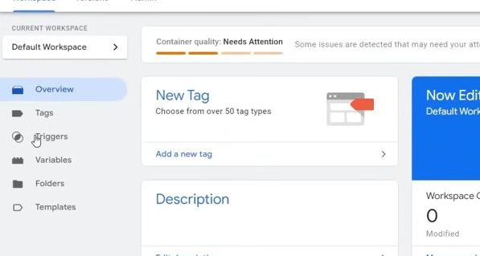
We come to google manager and create a tag

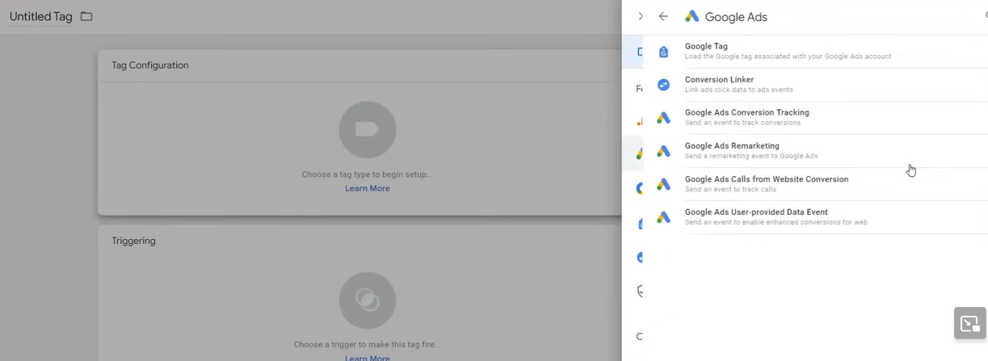
IN configuration choose Google Tags > Google Ads Remarketing

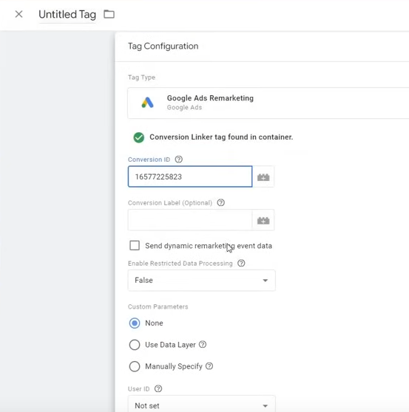
and paste the converion id there

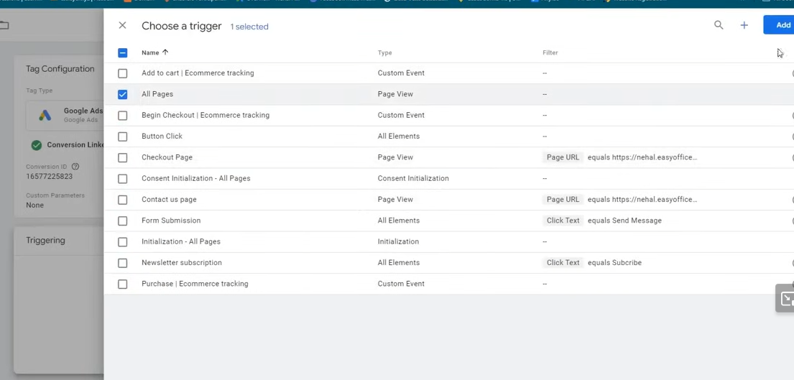
Now in triggering choose all pages

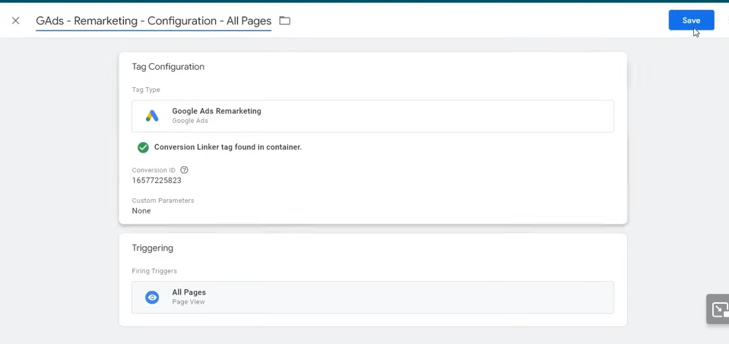
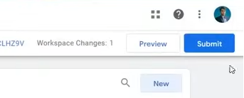
Now Submit it and then publish it

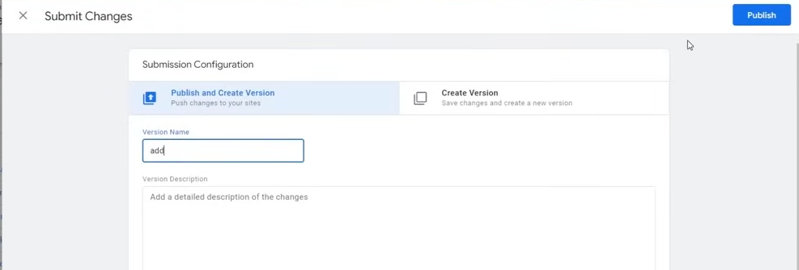
Now it will live

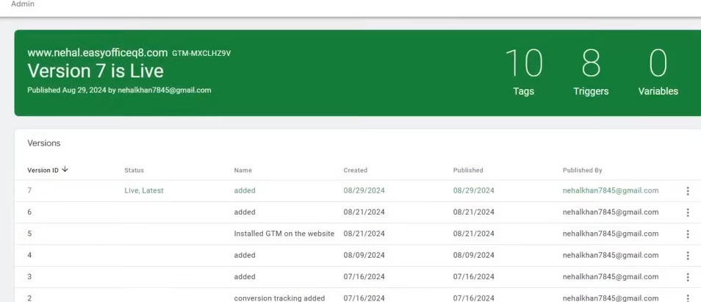
Now it means remarketing code is in our website

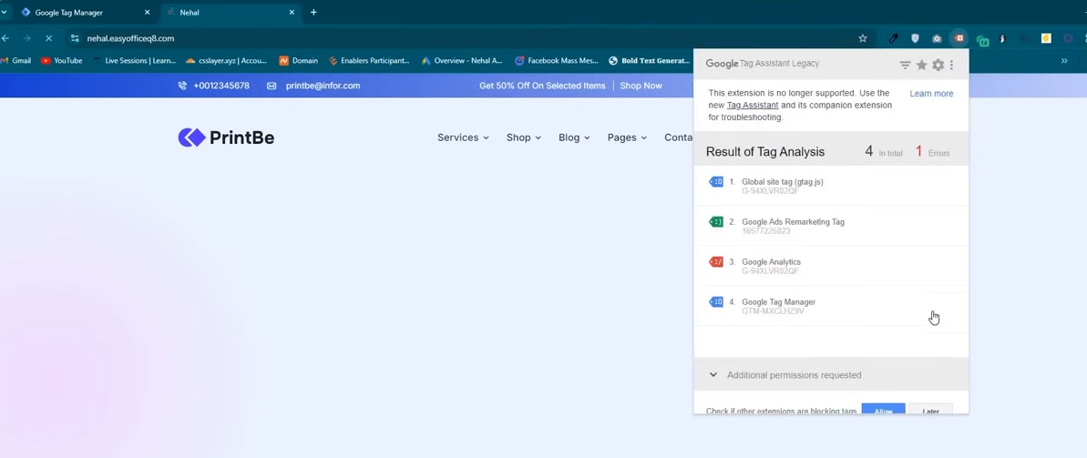
with the help of extension we check Gogole Remarketing tag
Since it is ther our remarketing code is in the website
So this is our first step and we have completed
you need to do it when you are creatin account and adding tracking then if you add it then it will be better later you don't have to add it if you add it lter then you have to wait and the audiecen will be generated and then yu can target it
It is better you do it intitally
Now whatever ou wnat ot taget you need to make a list of them
Now so go to your data segment

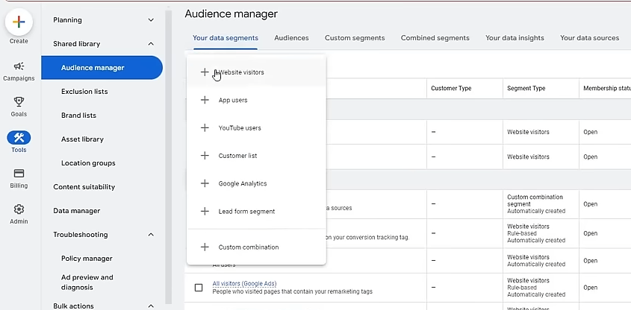
and then cliuck on +
Now since we have a website we choose Website visitors You canuse Youtube users if you have linked your Toutube channel to it
6:44:00
you can even import it from Google Analytics
So we clkick on Website visitors
Now the teacher will teach us how to make an audience

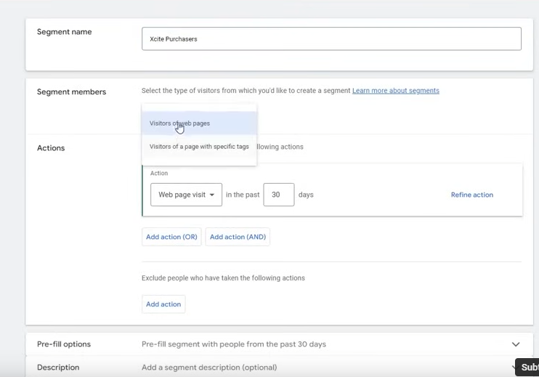
IN segment members we choose Visitors of Web pag with specific tag

Now choose the tag we made

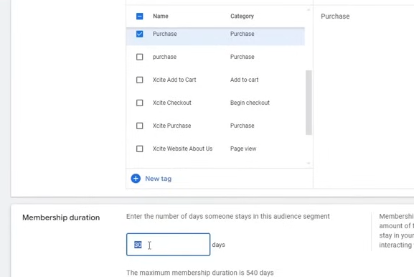
Now membership duration tell us after how much time people(gained by tags) will remain in this audience
Recommended is 90
Now click on create segment
Similarly we can maake checkout Audience

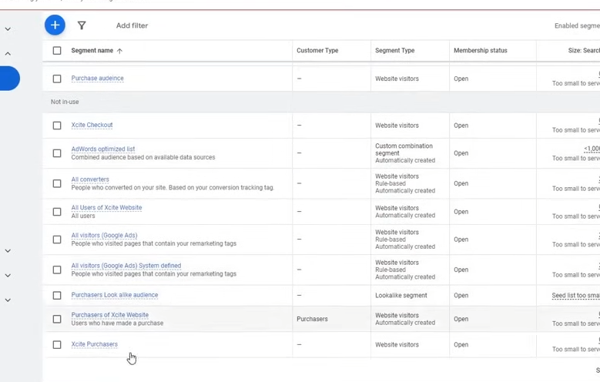
Some will be automaticllay made by the google itself

No we learn about Visitors Webpages

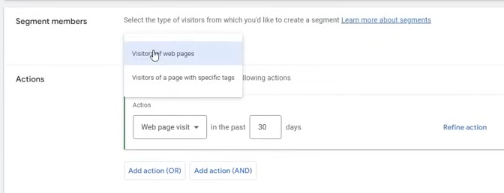
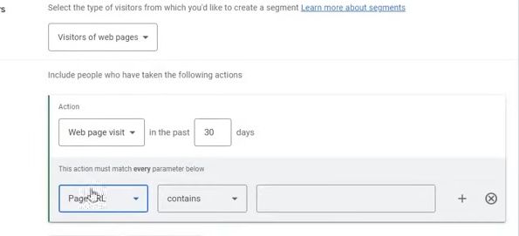
So here basically we are making an audienceon the basis of th eopage visits ina certain duration
Like we can make audience on the basis of people who visited add to cart in past 30 days

You can further refine it by OR and AND as marked above
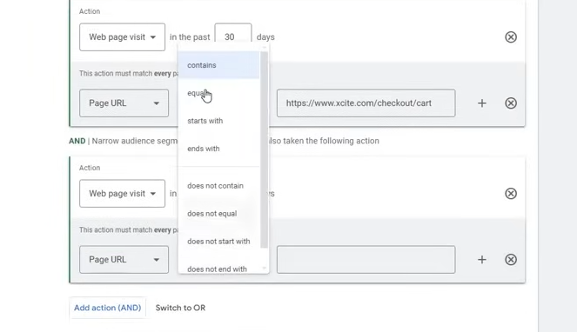
means visot on the bboth the pages or any of the pages
you can choose contains or equal

If you want to just audience of whole website
then use the url of the website not containing the url path

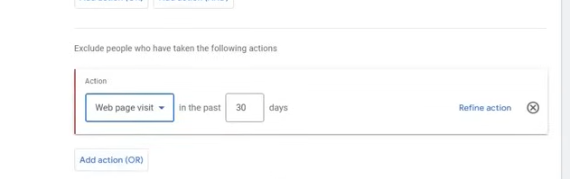
You can even exclude audiecne here

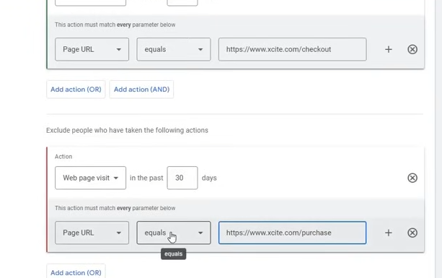
By above we make the audience such that there was checkout but there was no purchase
You can do so by making audiecne for chakout and then making audience for purchase
and then in campaign setting choose the checkout audiecne and exclude purchase

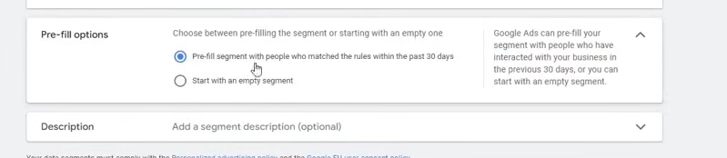
Now comes the fill option
If you have ads already running then choose the first checkbox if you have just started then can select second option

By firest option it will read old data which are matching with rules

In website with tags option we can select multiple tags

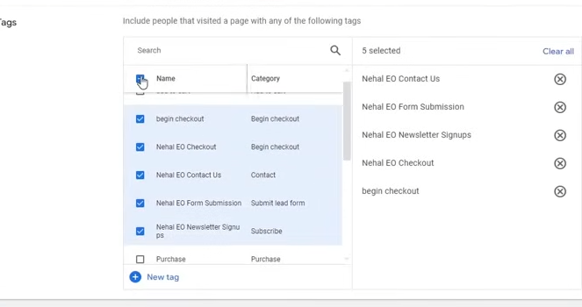
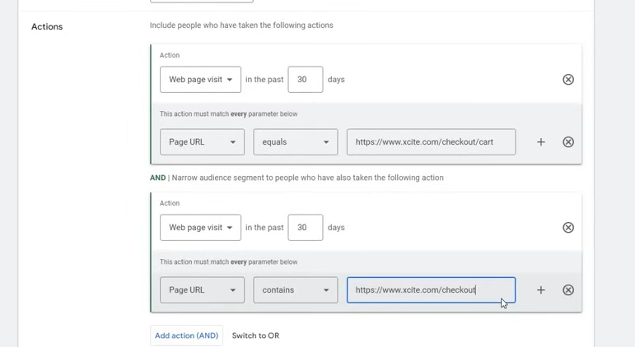
The above create audiecnce of visits add to cart and checkout

Phase 40

Now thats how you make audience list
It will not happen that you make l;ist and then diurectly you start runing ads on them
For some time teh ad must be running
For some time your ads is runnign and when the data will be enough then yoiu can run it
atlesat run ads for 90 days when you put consderble amount then you can do maarketing
It does not hapopen that you do marketing from first day
IN some cases ehn there is insane amount is onvolved then you can run ads on those audience quickly otherwise it is not possible
Now you have made the audience but how you will make a remarketing aaudiecne
Like a normal display ad you set up your campaign

ou can so so during making pr after making

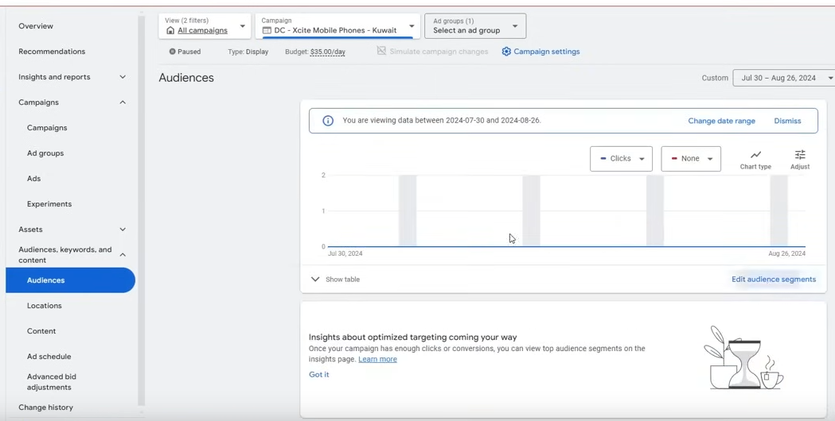
Now you can go to Audience in side menu
and hten click on edit Audience segments

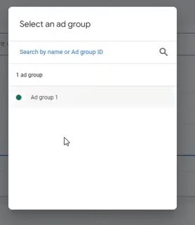
choose the ad grouip

and then click on teh graph

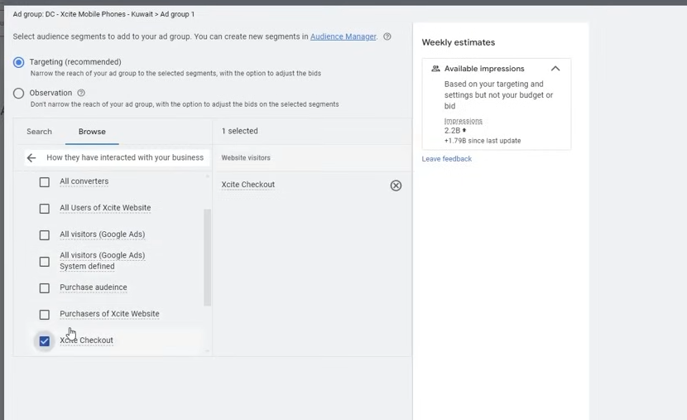
and now choose the aaudience you have made for remarketing
and then click on save button

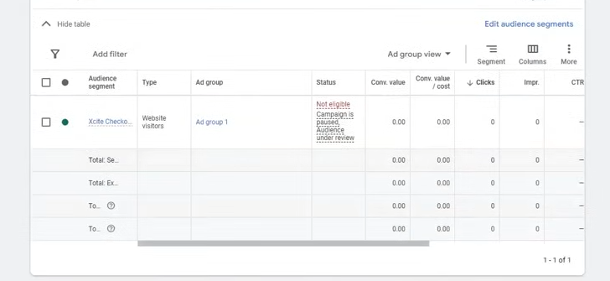

Noww it is showing the ads

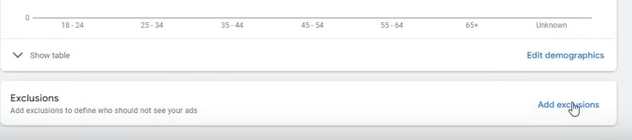
Now add exclusion similarly you did it with audience

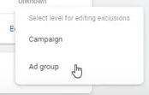
Choose caampain

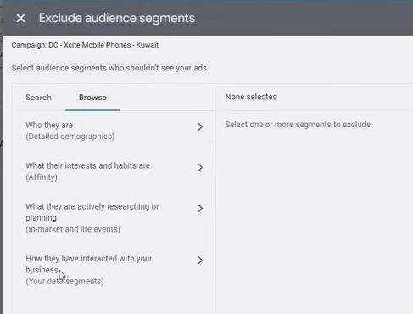
That how a remarkeitn campaign is made here
ou can run remarketing campagin in Displaay ,video and Demaad Gen

We don't use search campaign becasue there is very limited data here and limited searches and you put remarketing adience there then it will not run proprly basically get stucked

Now we will see shopping campaaigns

Lesson 19:-
In this lesson we will learn about Google Merchant Shopping Campaign

Before doing ther are presteps you need to do
Mainly shoppng campaign is for Ecommerce
and Performance Max Campaign is for Ecommerce
Teacher will tell us how but consider it for a powerful campaigns for Ecommerce
you need to set some pages without them your erchant center account will not get approoved

Merchant center account where your all products will be uploded there and it run it in your google ads
Without this steps it would not be possible
othewwise you will get a suspension of misrepresentation and you will get a lot of problem
So it is important to solve this problem beforehand

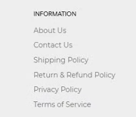
The last four are the pages which are must have . Without this you don't have any Ecommerce or store
You need to add correct information there that is in which date you give return
and if you need to return what is the process You can view other website pages how they have made these pages
So always try that the policies mentioned should be followed in bussiness also and put that in you webssite
About Us and Contact Us are importnt pafge for us

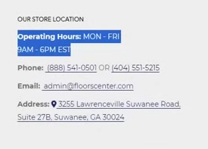
The above information are also important for us

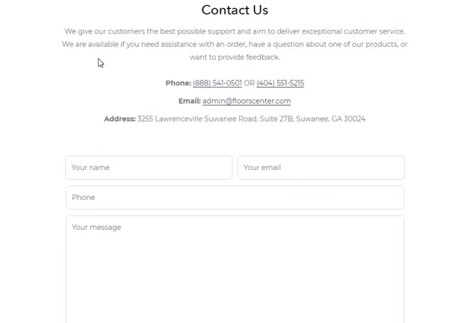
In Contact us Page you need to mention Phone , Email or Address
teachrer recommends also add timings that when you will get reply
and then there should be your form
Thease are imporatnt htings wwithout this Google will not allow you to run merchant ads

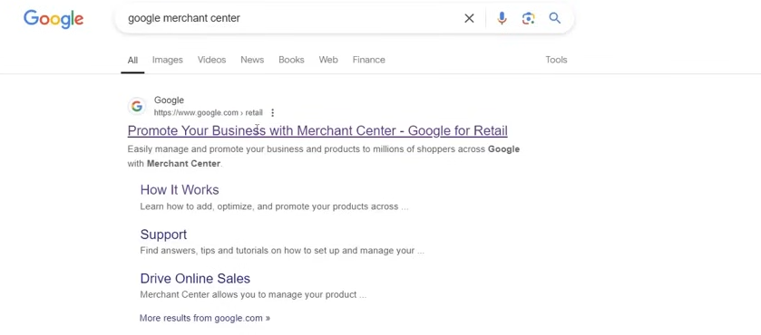
Now we come to Google Merchant center

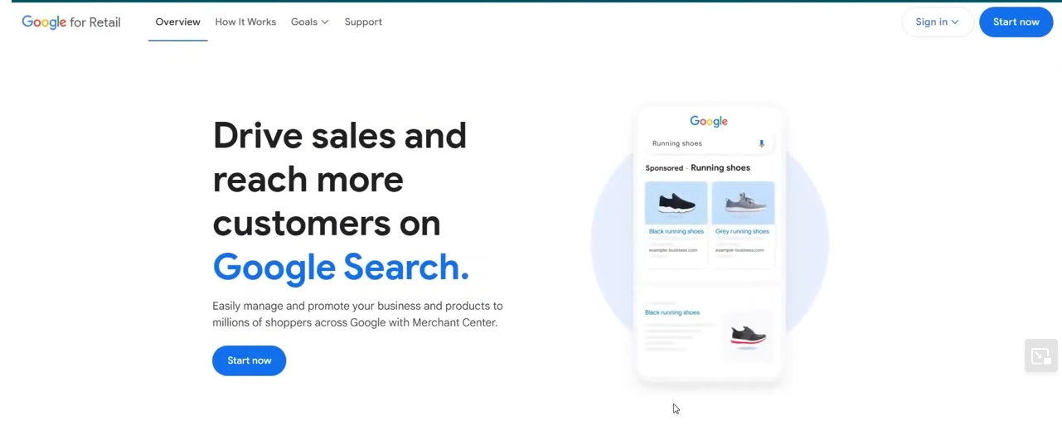
Here your products are uploaded and products are imported on your website aandGoogle keeps the data here aand from there the data is imported into Google ads and from there you can run ads
It is slightly technnicl process but it will be easier
because teacher will tell us a way that you can do wothout any technical process or technical things
you can do it

Go to How it works
To do Merchant account they ahve already made some plugins or app
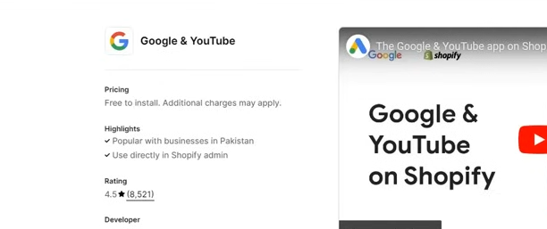
You can add tracking to your website especially in shopify you can do so with the help of Google And Youtube apps
If we follow the proess teacher used in shopify then we don't need merchant becasue then your products will be uploaded there
So if you use this aapp with shopify then your mercahnt aaccount will b automatically created there
adn your producrts will be uploded there automatially and you don't have to do technical thinsgs here
So it will be take product from Shoppify store and put it in your merchant center store

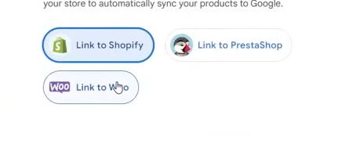

Now this was about shoppify No we will see for Woocommerce menas wordpress

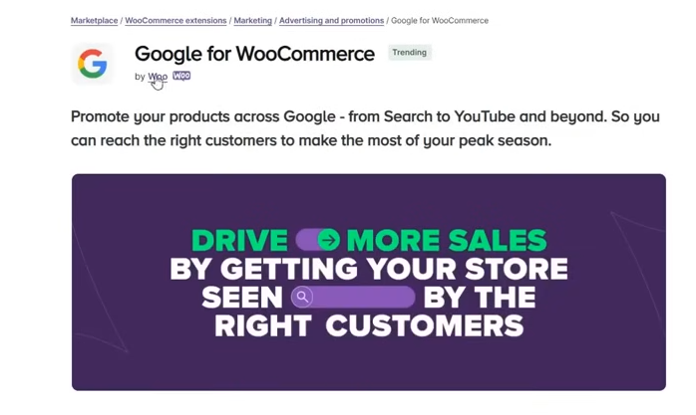
This is basically the plugin that is used to set up our mercchant center
It is similar to shopify Here also you don;t have to do any technical thing here or you don;t hve ton make merchant center here and you get the option here.
6:58:30
and you creatr your everything here hatver information or setting is in your woocommerce it picks it up and it send it and the product from your site is placed in your website

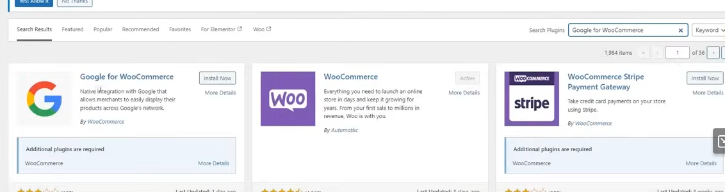
Now you can install it here
After you activate It will tell you already steops like you mak einstagram or facebook account it is similar to this and you need to follow the step it is telling you
Don't mis nything
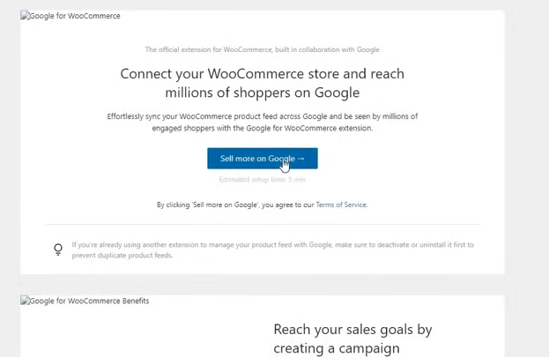
Then it will be properly set up
So click on sell more on Google
It will make you automaticlally a merchant center for you if you provide correct information there then there will benno problem

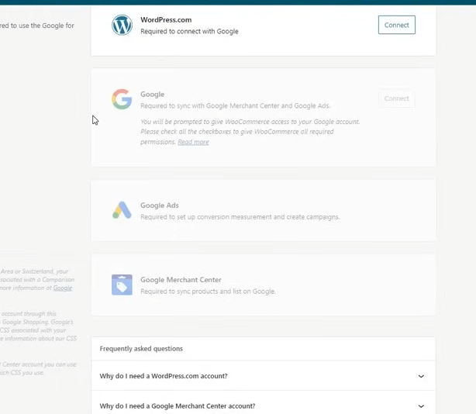
You need to nake sure
Phase 41
that your one gmail has access to all that is google ads , Tag manager , Wordpress etc If you keep one email then your process will be easy
If you don't have then you will get the optoin to create( who knows )

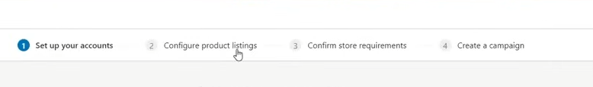

You will asked your address , Phone number , Bussiness name and then it will be formed and your products within 24 hours will be uploaded and how you check it by using that email to login into merchant center and then that merchant will come which it has made for you

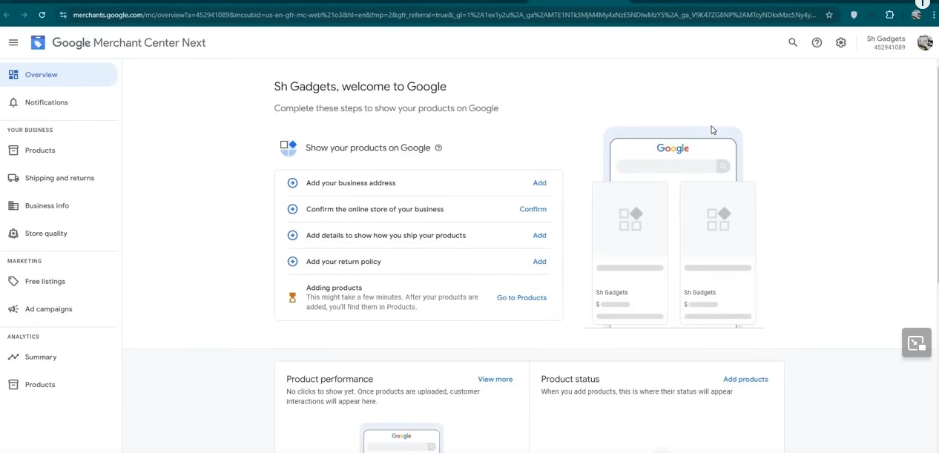
Now you need to double check everything becasue it oftern happnes that some wrong information is coming from your store and there is some mistake

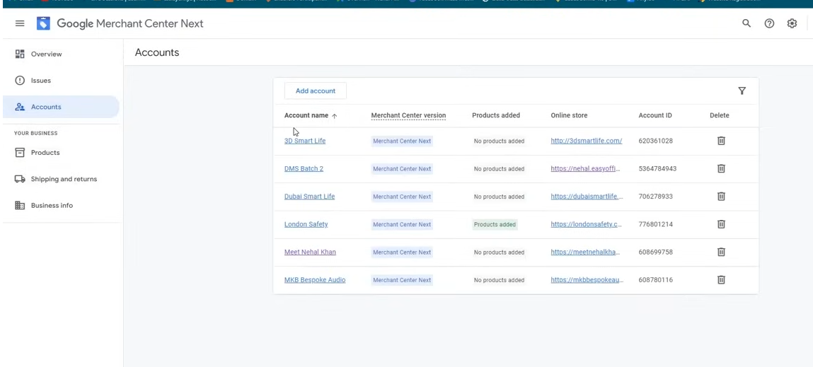
So you ned to make sure to check everything
we choose one of teh account listed above we choose teh bottom above

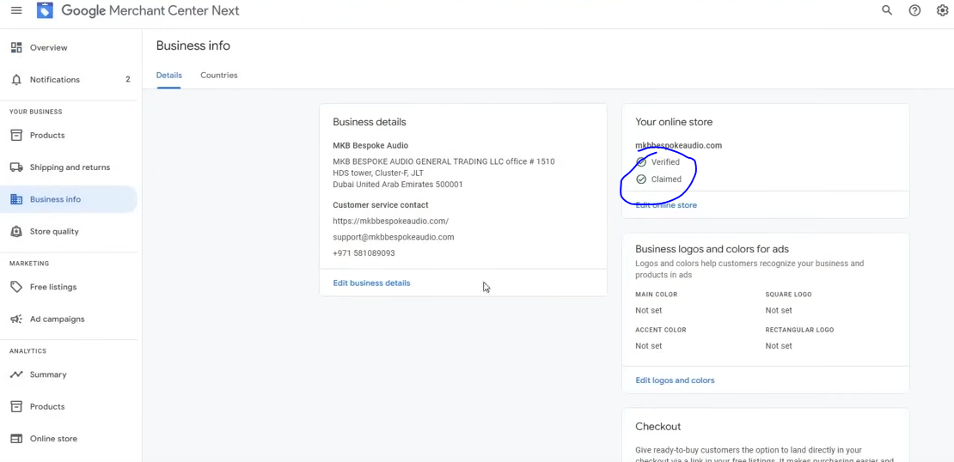
Now go to Bussiness info and confirm our information
It should be verified or Claimed as marked above
These things need to be confirmed
Now come to Shipping and returns
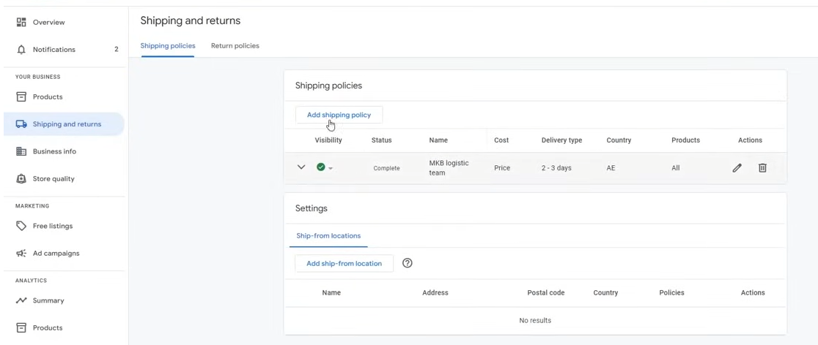
the shipping will be automatiacally made if no then you need to make it according to the policy through the company you are shipping , In how many days are you shipping it will ask you all and your shipping policy will be completed and make sure the information your are providing that information should be present in the website otherwise ther will be matter of misrepresentation

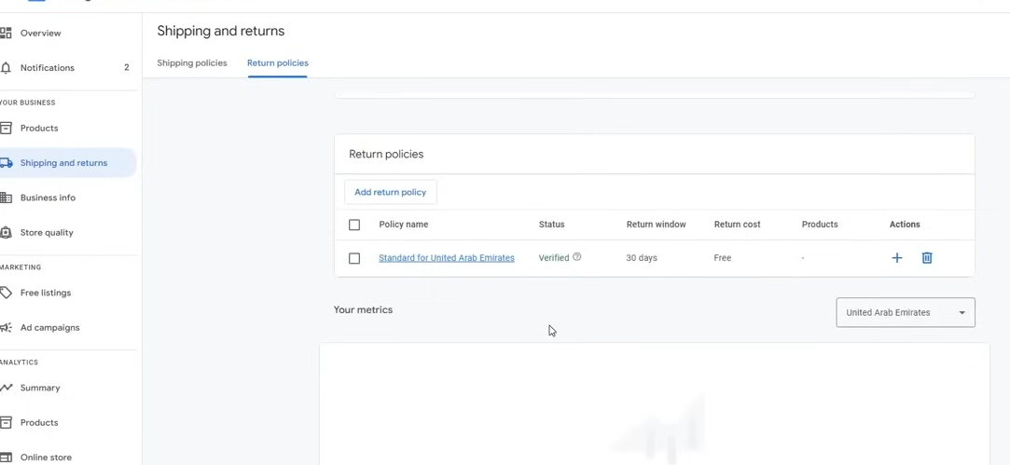
Now go to return policy
It will ask the link of your retiurn policy
Make sure you set up the page
If you don't do it then your merchant center may get suspended and problem may arise
If still susopension rise then you need to conatact with Google Team and tell the we have done everything correctly and cooperate with you to tell your mistake
Go to help and then in contact us you can talk with them
You can email , chat with them So these were the pre steps that are manadatory to be done
without them you canot run ads for Ecommerce.
7:04:00

ther eis another thing called Google free listing

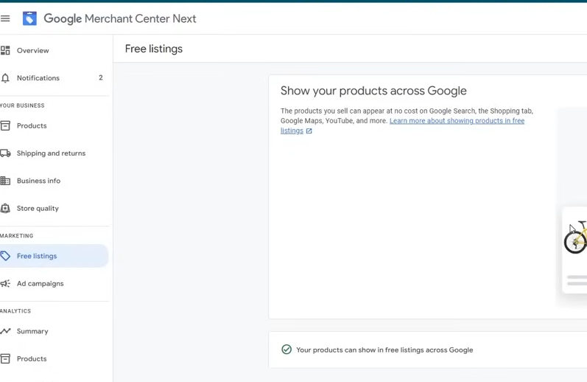
Google has its store We can do seperately shopping in google while searching (who knows) There also your products get listed in free means you don't have to pay any money and don't have to run ads nd they are listed free and you get good trafic there even the sales also come

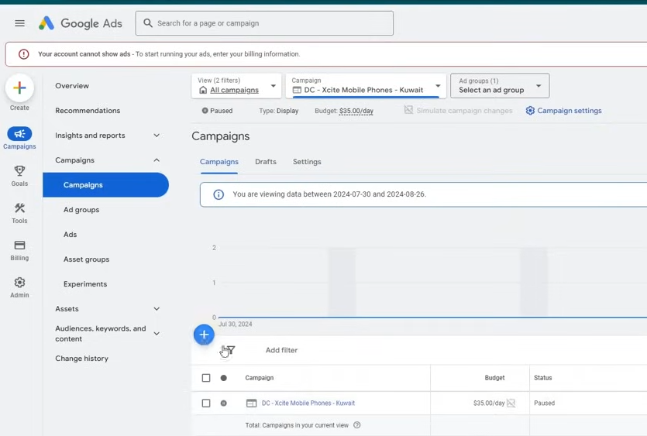
Now we come to campaign setup on how to make a Campaign
Noe in new campaing we choose saleas as an objective and then continutand then in type choose
shopping

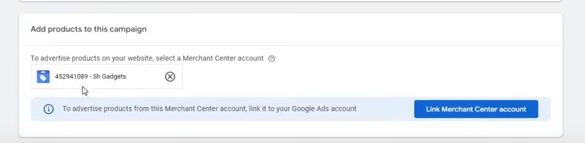
You need to link Merchant center here
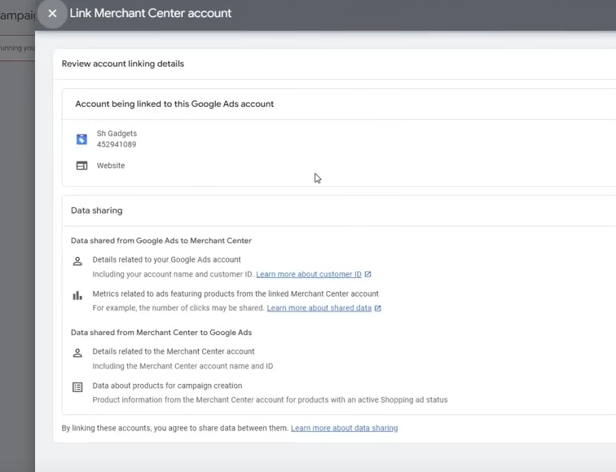
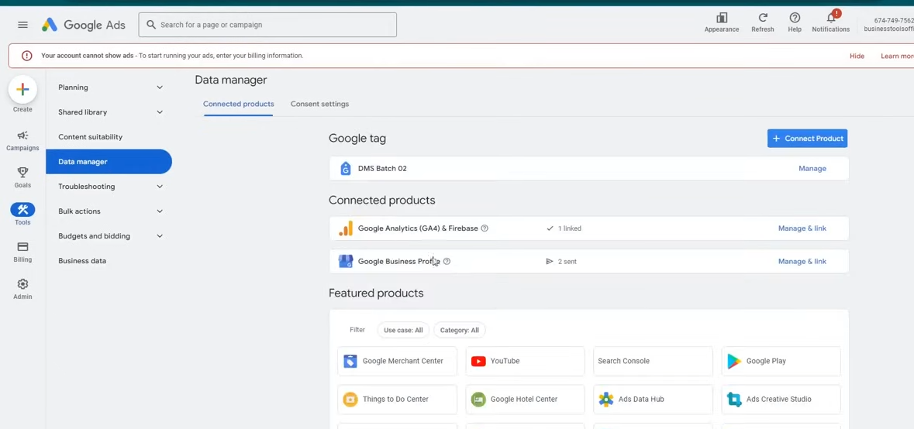
Now go to Tools and then to Data manager
and then link your mercahnt account there
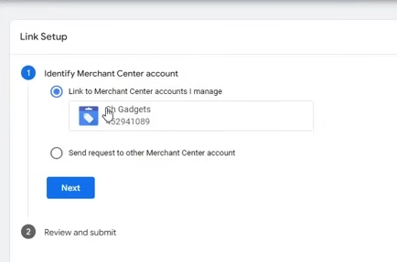
If this is the email then you get the option
but if you choose the second option then you tell the email hich is associuated woth the Merchant center

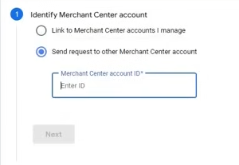
and then you accpe the linking in Mercahnt center

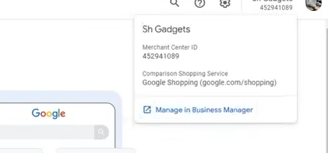
The above is merchantb center id
Now after linkin you can cnontinue your making of a campaign

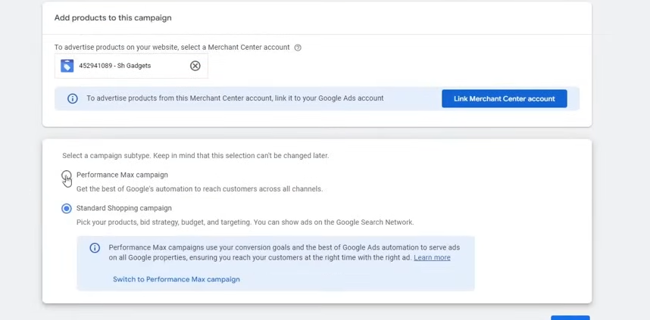
Now theMerchant center will be shown
We choose Standard Shopping cmapign we will see performance Max camopaing later

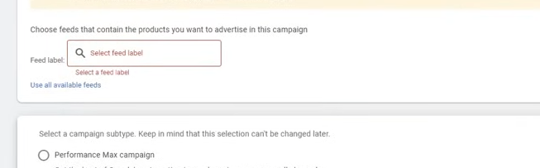
You can select a specific feed(I don't know)

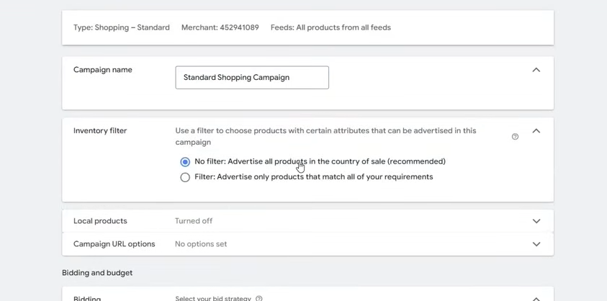
Now name the campaign and then in Inventory filter if you choose then No filter will be aplied and all the products in teh merchnt center you termed as sale will be selected
If ou choose second option then you choose specific folder according o your requirement you wnat ot run ads for type of products

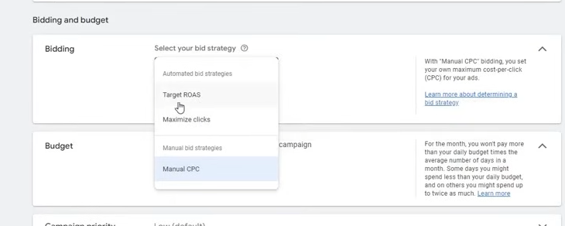
In Bidding you Can choose Manual CPC , Taret ROAS, Maximize click

You can do target ROAS only if you have enough data

you cn set budget upto 30 dollar
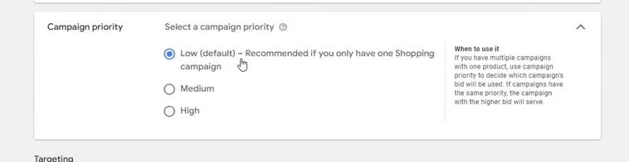
Now in campaign priority you need ot leep it low if you are running oly one campaign
If you are running a multiple campaign then for ecample for the whole store we make a campaign
but then we make another shopping campaign which we run on only laptop category then for that we will choose Medium or High by this whaat will haopen that if two campaign are running then they will not compete woith each other
It measn oif the laptop ads is running then Google will focus on the cmapaing which is madw for laptop So it is maade for that purpose
You can start bid by 0.25
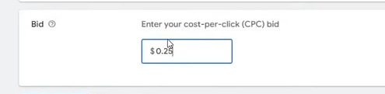
If the results are not coming then choose 0.35 or 0.45
By the time need to increase the bid if you don't get the desired result
do the chanhge after seeng resilt in two or threee days
So you need ot increae it sowly so that you don't increase it too much and don't keep it too low
Now click on create campaign

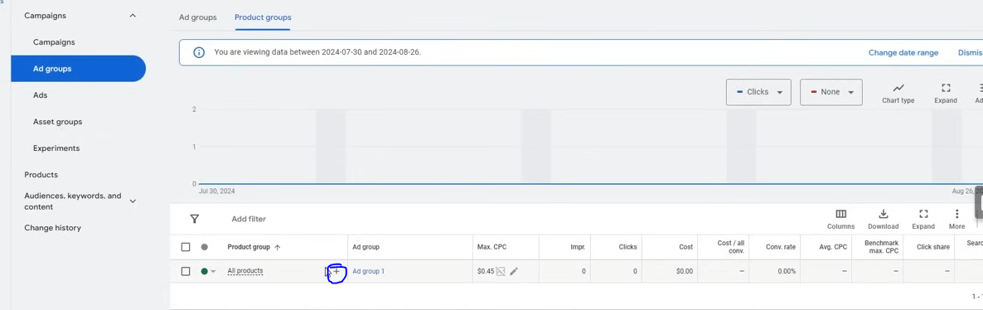
you can see CPC above and many other details
Now if yoiu click on marked area hten

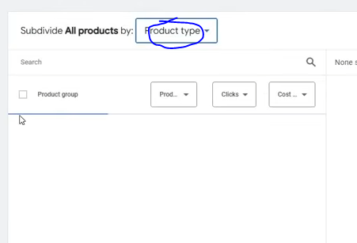
Siunce we don't hve any product now it si not shoing anyhting
Now click on the marked above
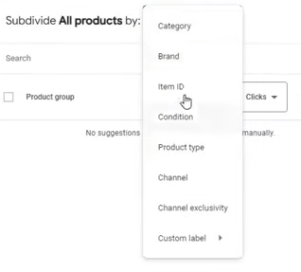
and then in submenu click on item id

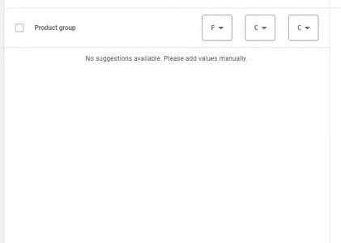
then a bar will come her and hten go to bottom and hten cloick on select all and then add them

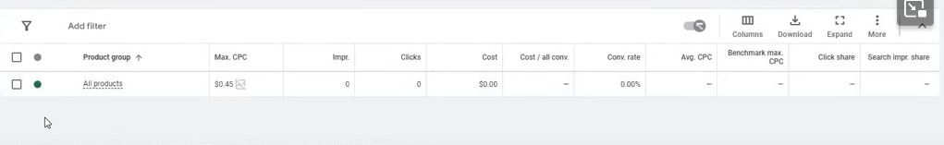
By this what will happen that you can see in tha ALL products fild it is not showing our products
Normally it must be happening with you
But if we add aubdivision like the teacher told you then every product might be coming to you and in every prodiuct CPC must be showing
Phase 42
So it is nused for that purpose

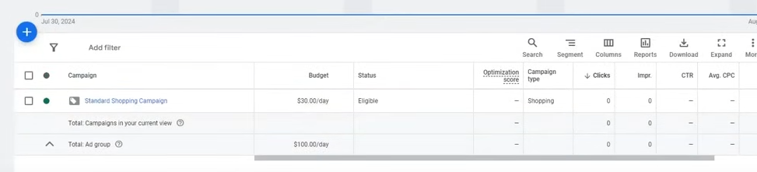
So now standrd shopping is completed
Our Necxt topic is Performance Campaign

Lesson 20:-
In this lesson we will learn about Performance Max Campaign
this is our last and final camopaign type that is
You need to do the same thing there you done in merchant center
you don;t have to do the steps we have dome already
Now in ne campaign choose Performance max in campaign type
or you can choose Shopping and then
choose performance Performance Max Campaign in camagn subtype

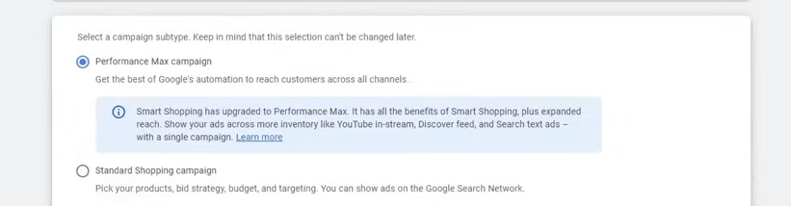
and hten click on continue
Now in bidding choose conversion value if it is being tracked
aand if ou product preice are varing thne it is understdable to use caonversion value
becasue diiferent values products are available now you would want that more value product should be sold
but you choose conversion when your product price is not too much and there is no price difference between them then you choose conversion otherwise not

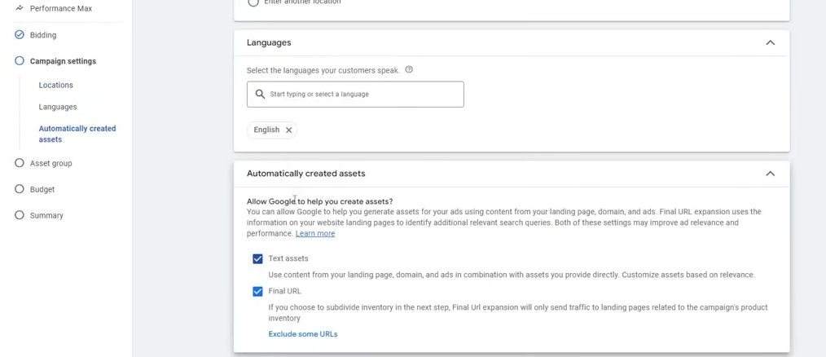
Here you will get additional option which is automatically created assets
for your websites
By using website link it will generate headline or desciption or images
You either use it or use chat gpt manually
click on next

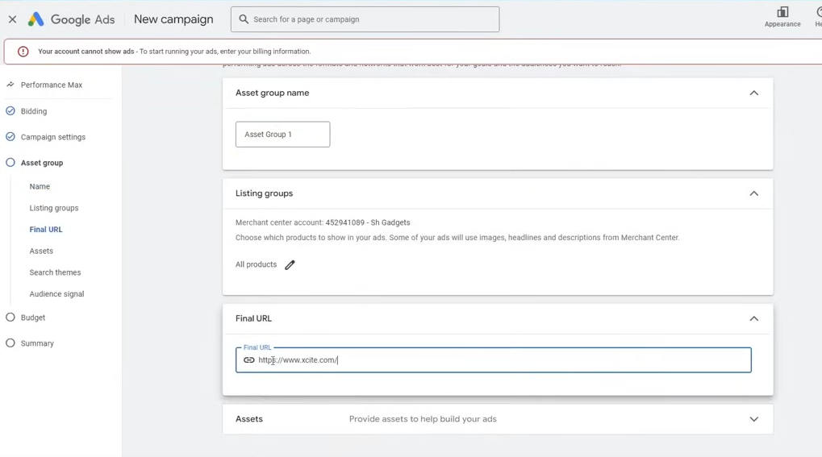
Now give the url
Name the assets group(I don't know)

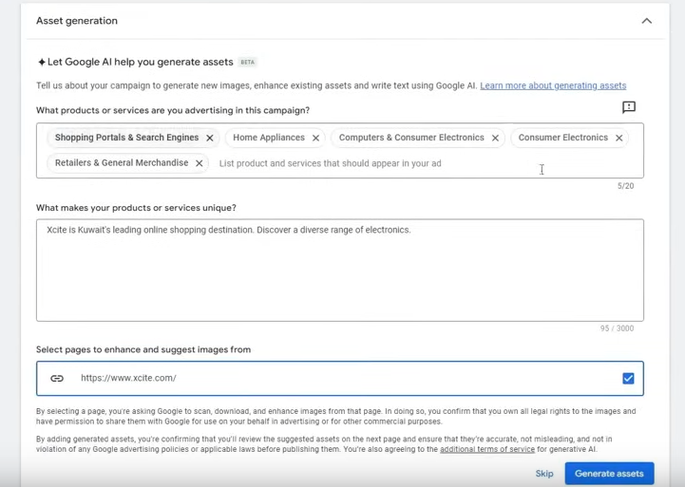
IN asset genation it i shoowing wht headline it did pick up from the website
Now if you click on generate assets then it will creat it so
The best opractices here is that you need to include 15 headlines here and 5 desctiption and 5 text here
If you add 1 or 2 logo then it will be enough
If you have video then you can add it , add bussiness name you can aadd cal to action
It may look like display campaign

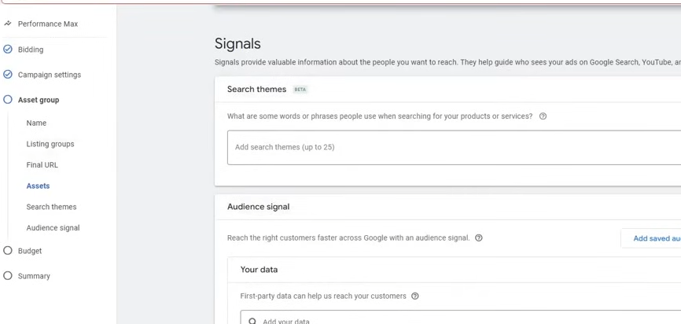
Now comes the signal we made ads nowwe come to targeting
Here you get additional Now you need to make signals means what customer is searching you need to give idea to teh campign so that on teh basis so that it can generate audiecne to target and show them ads
The easiest way is to go to Keyword planner and then get the keyword thriugh url
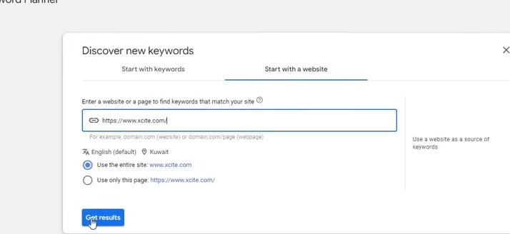
chose first to generate for all and choose second option for generating keyword for specoific cateegory
Add all the 25 keyword in signal it will be good choose the relevant one here by this your campaign will go to relevent audience otherwise your campaign will performance you can also add from your mind
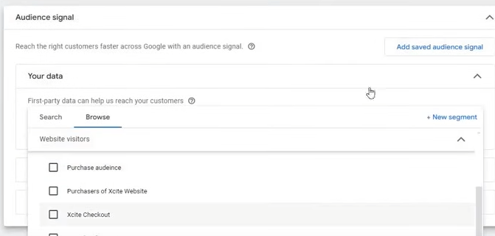
and now in Audience signal you can add your own custom audeince

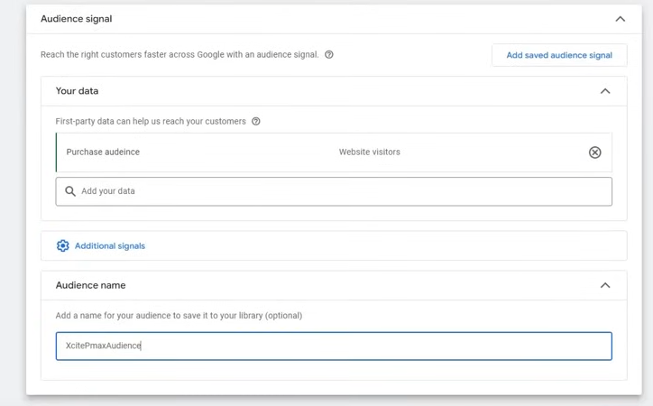
Name the sueidence youselcted for targeting for this camopagin
you cannedit audiemce and choose their demographics , custom audience.
The signal and then audiecne targeting is important wwithout them campaign does not perform
And now the campaign is comleted
and where this caampaign will be shown the teacher will show us
This will be shown in below platforms

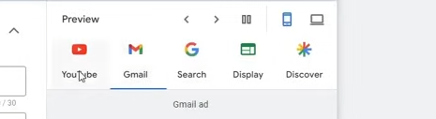
The merchant center we connected to it will be automatically will run there(who knows) , aautomatically will run on this ad means ad will run on the product(who knows) and also on al the products (who knows) and it will run on every platform.
7:18:30
and run witrh evcery product so teh chances of sales invceases
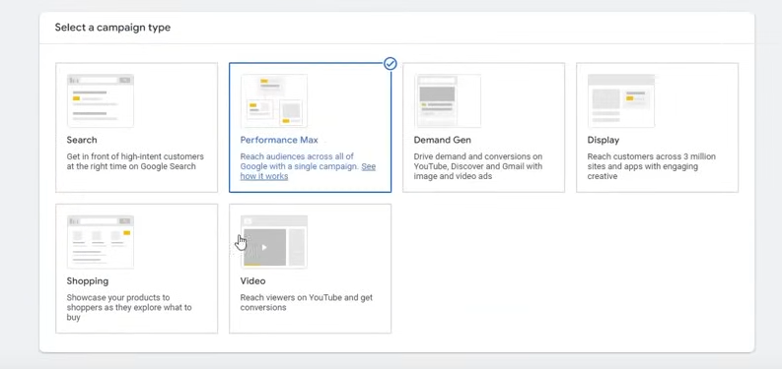
Now we agian create a campiagn of by Perrformance Max as shown above
Normally teacher create by this way
Another thign is that Performance Max cmapaign with feed
The feed are teh products registered in Google Merchant
I don't know

If you want to Make Performacne Max Feed only hten you need to do some additional steps
You just need to create cmpaign in similar way
Phase 43
By any way you need to complete it
The assets we made does not caontain real data

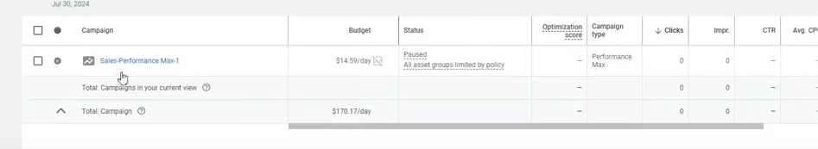
Now we go to the camapaiugn we made

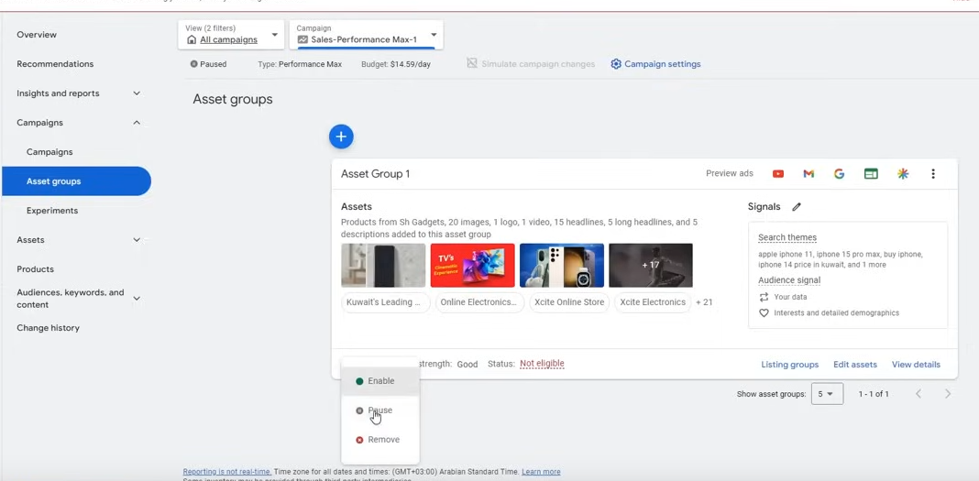
We come to asset group and pause it as shown above

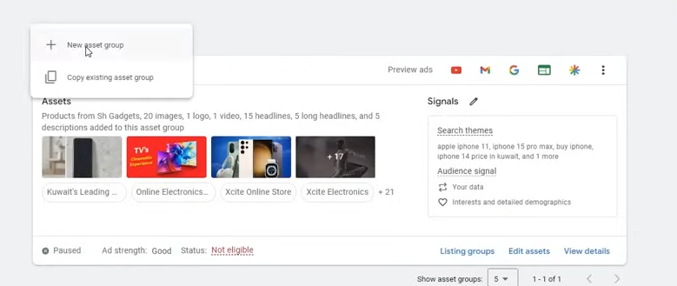
Now we create new asset group
Where we will not add any headline or description
you will not even add signal you just need to add your product feed and Product feed is enough and then you does not need any Hadlines or anything and then save it
Just add the url

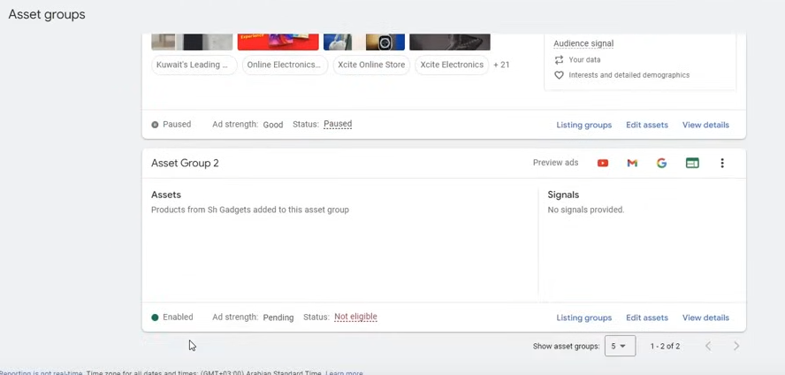
Now we made a Performace Max feed campaign
These are teo campaign type which is used for Ecommerce and we get good result through it
So this was the topic of Performance Max Campaign
The Shopping Campaign is 100 percent for Ecommerce and the Max Performance campaign is 90-95 percent campaign and 5-10 percent is for Lead generation
Peoloe use it but its result are not any special

Fun fact:-

Search Campaign is mainly for Lead Generation
Display is used for Remarketing
Shopping is for Ecommerce and
Video Campaign is for Remarketing
and universal App campaign is for App promotion
Demansd gen is for Remarketing and trageting General audience
Dynamic search ad is for lead generation
and call only ads is for Lead generation
Teacher has told us campiag whoch used under specific category

Now our Performance max is also complete
Now comes the last topic that is optimisation
Now we will learn about optimisation
Now we have run our Campaign and did everything properly
Now e wnat to optimise it then how to do this

Lesson 21:-
In this lesson we will learn about Google Ads Optimisation Part 1
Now our last topic is optimisation How to do the optimisation and after how much day and how to do it
Now we open a live account
The first type of optimisation is Search term optimisation
This optimisation happens only in searc campaign and not on other campaign
Now what is this
Suppose you have added keywords like Laptop Shopping and someone search Mobile Shopping and someone click on the ad hten it is irrelevant click you have to pay the cost for it If you excliude then your cost will be saved So thatcalled Search Term optimisation
We remove certain search term that are not benefitial for us or relevanmt for that we go to tools

